**Azure AD B2C**, **Microsoft Graph API**, and **API authentication**

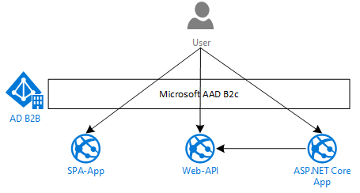

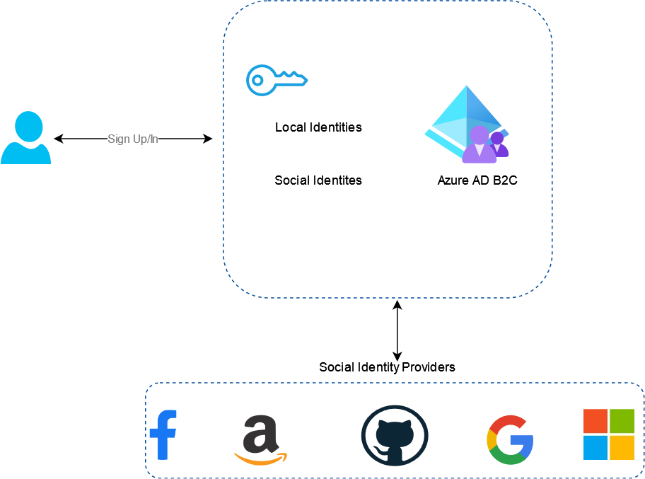

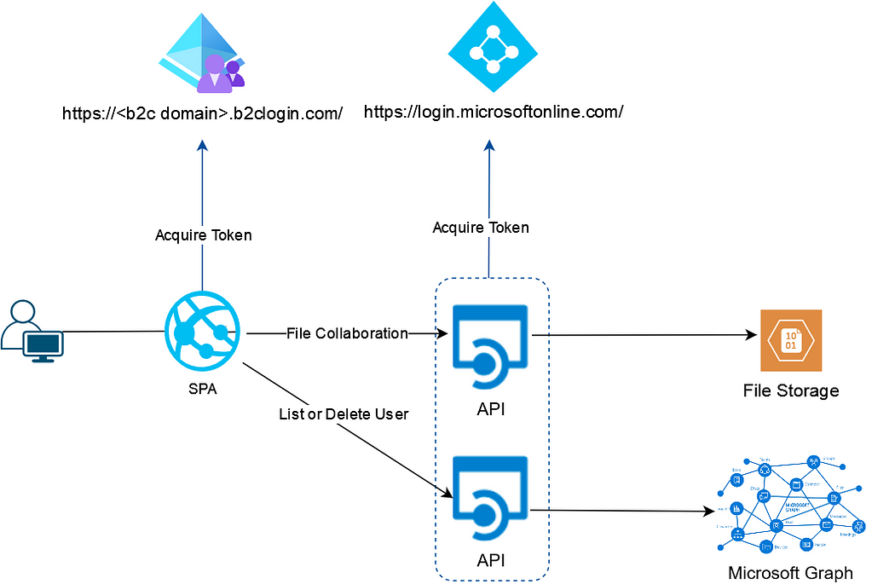

we developed SPA with MSAL for Angular, Azure AD B2C user sign-in sign-up flow, Azure AD B2C protected .NET API and user account management through Microsoft graph API.

**Infrastructure Architecture**

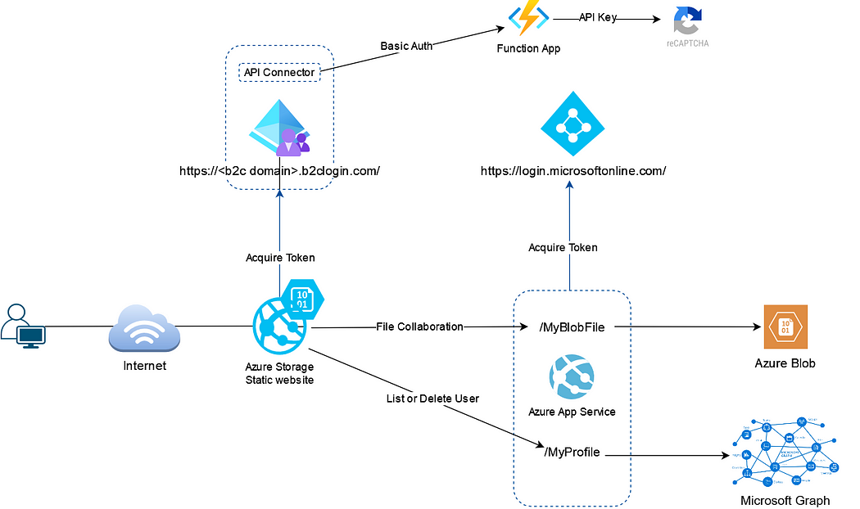

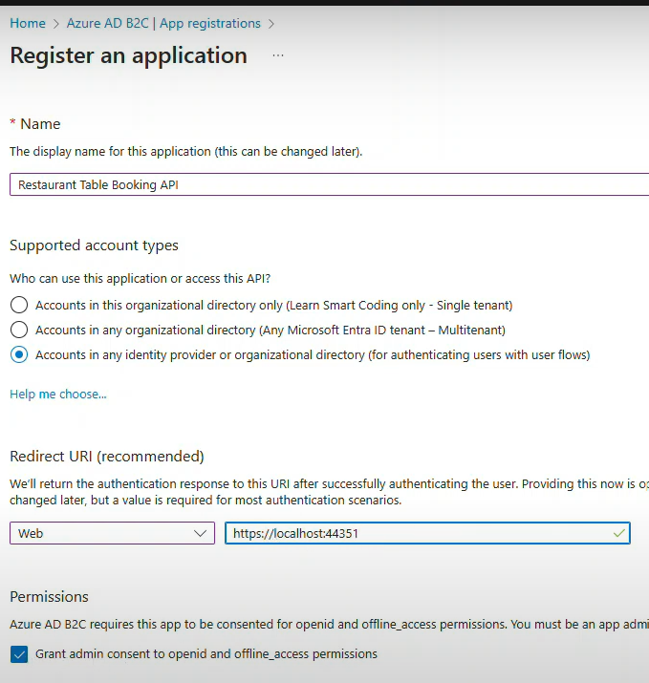

All scope will be inside url

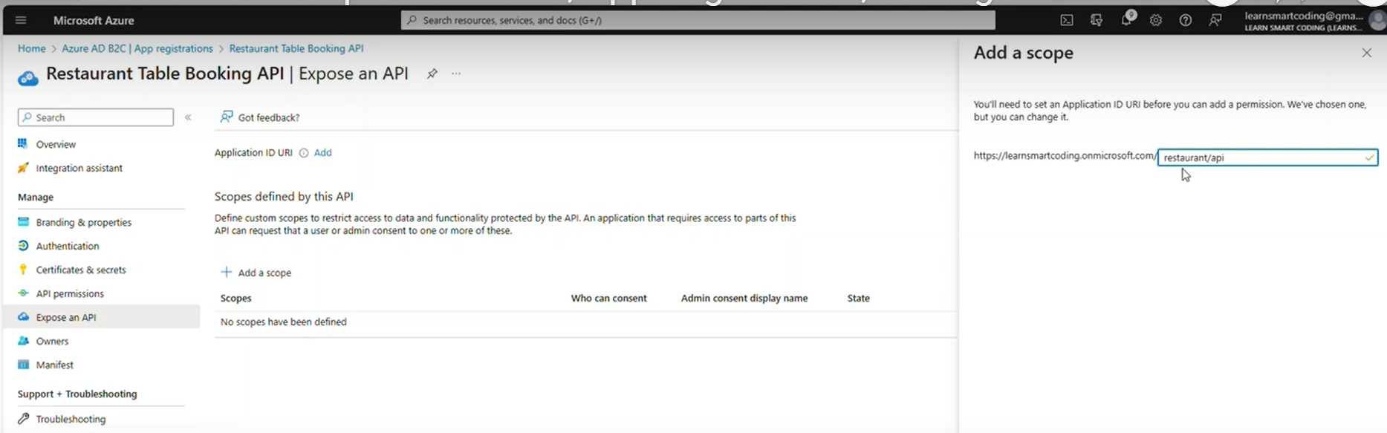

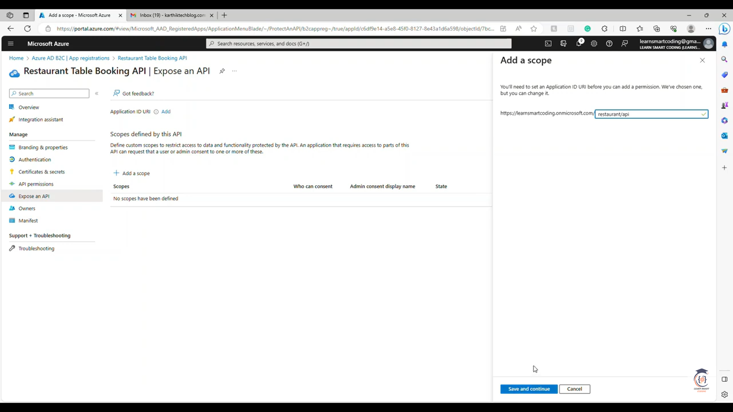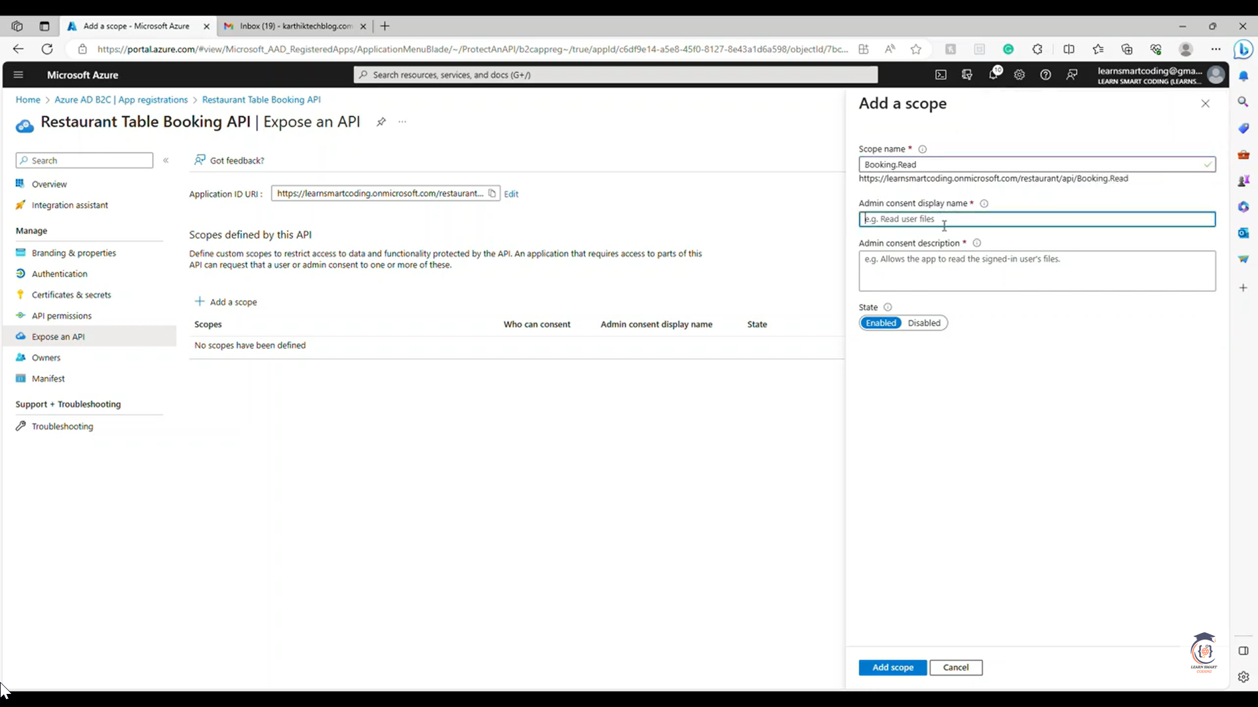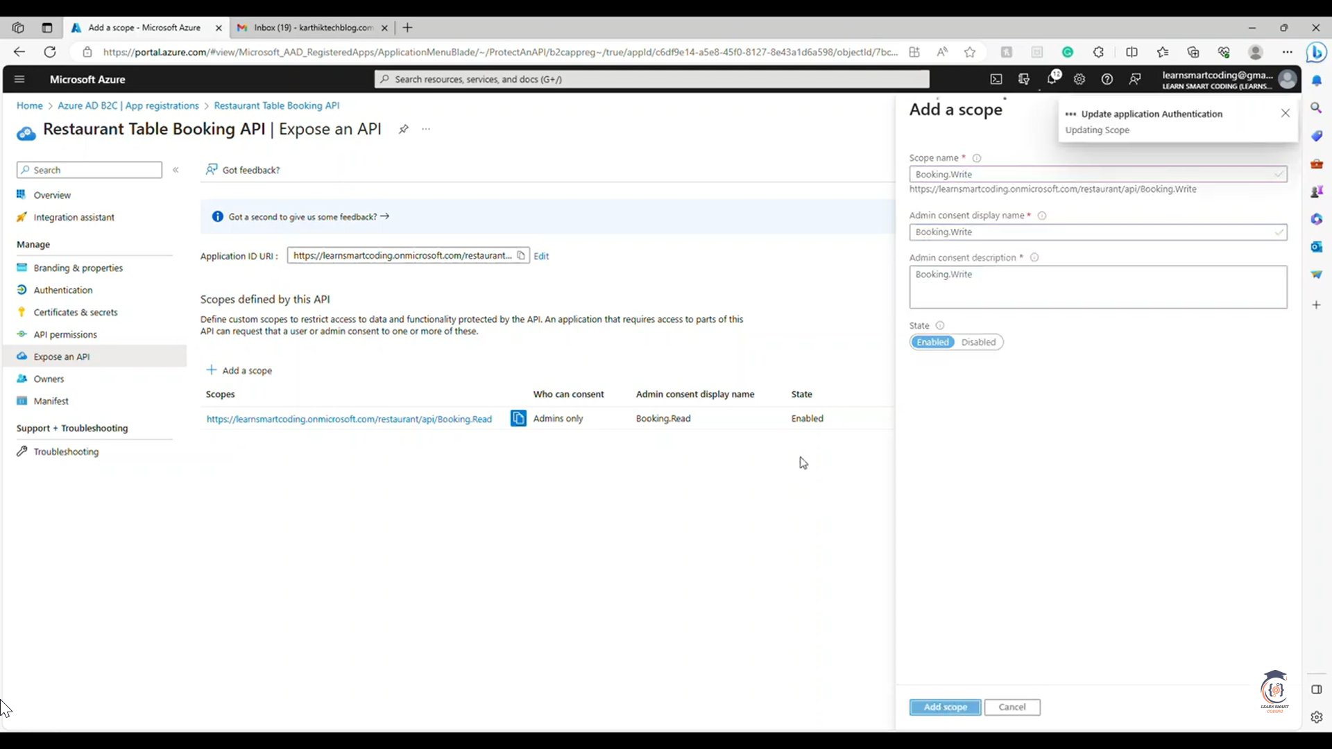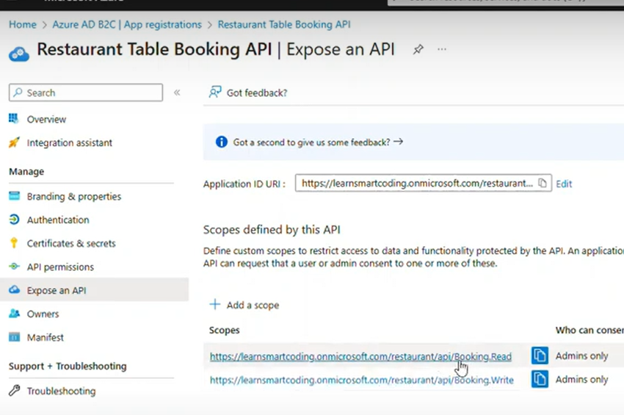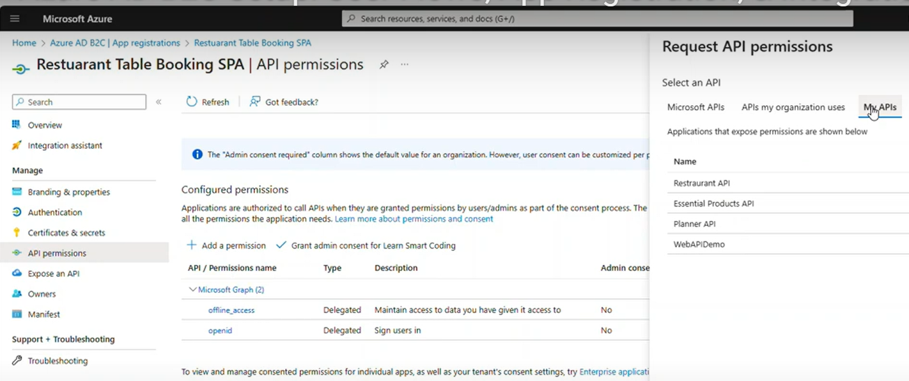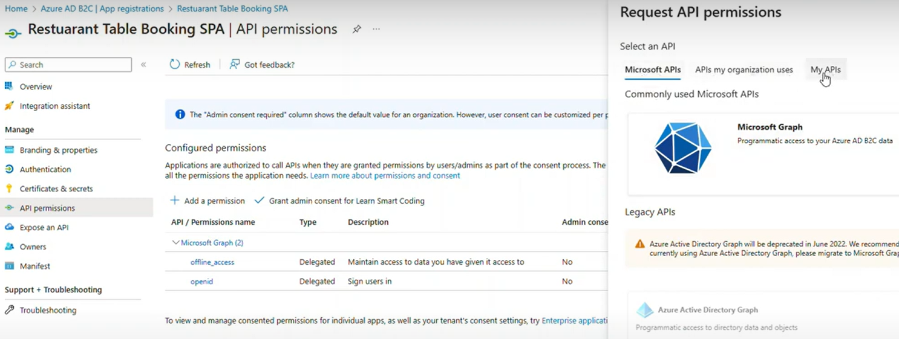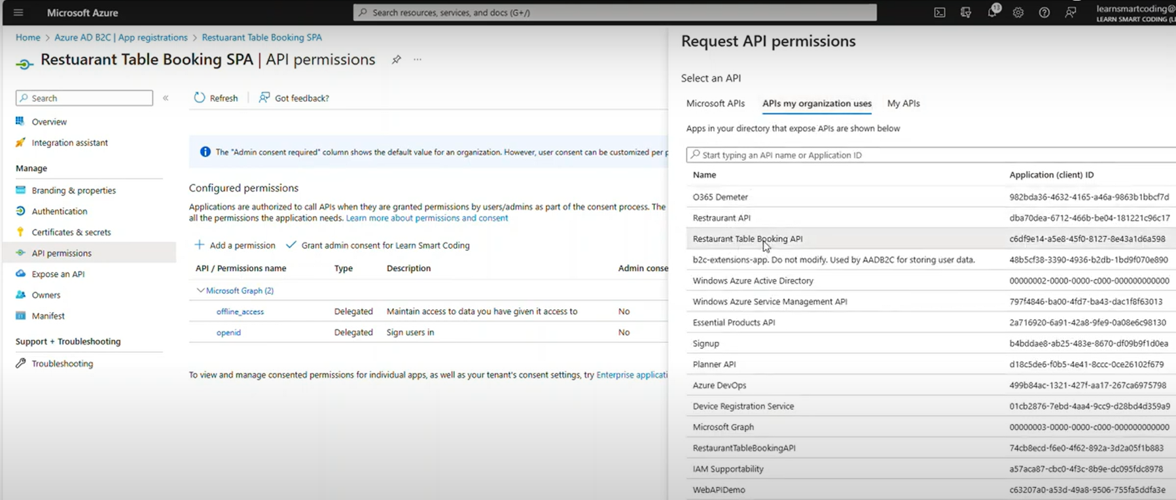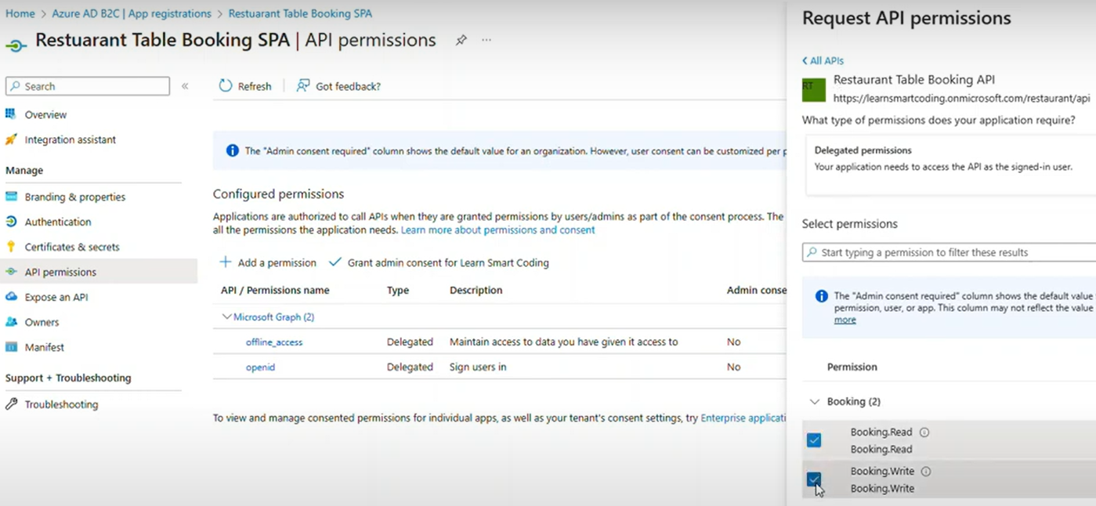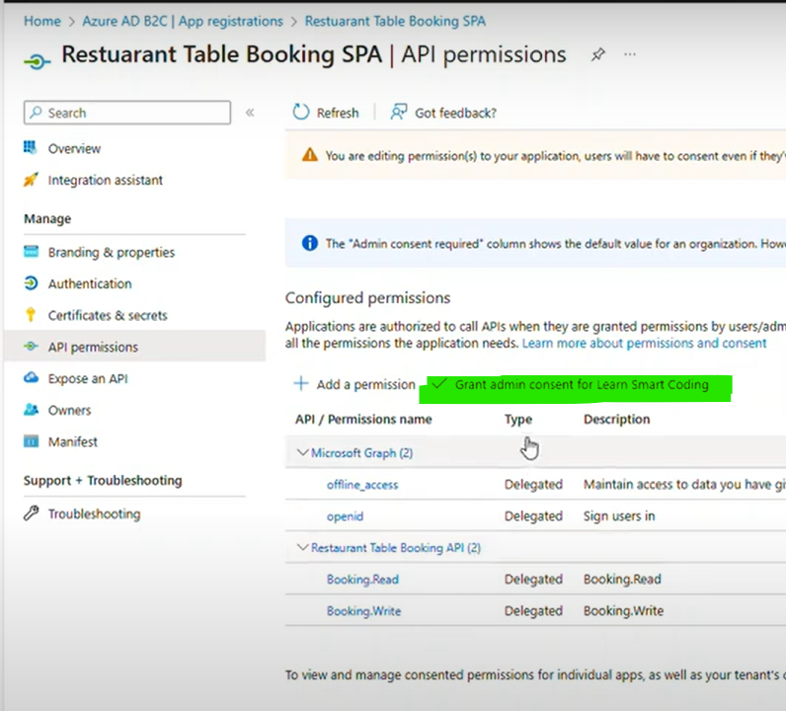

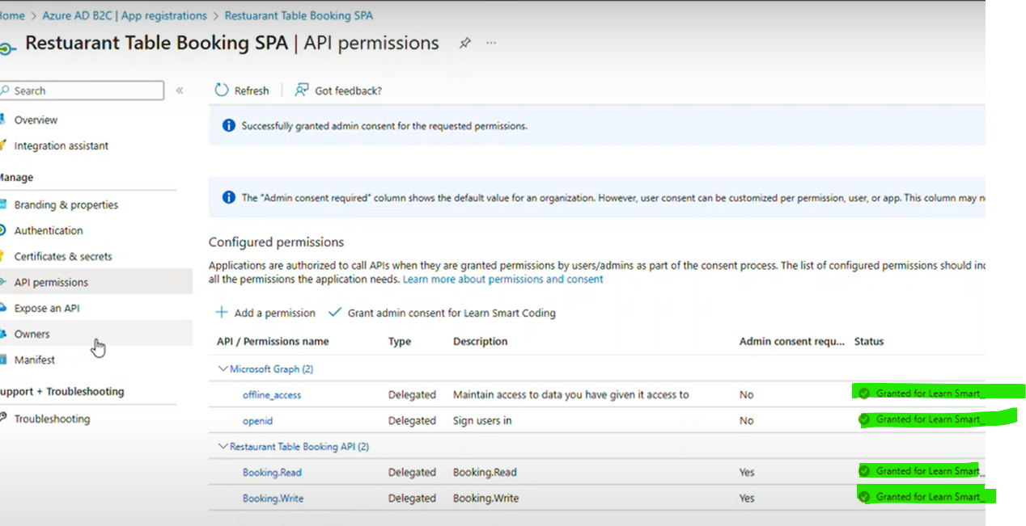

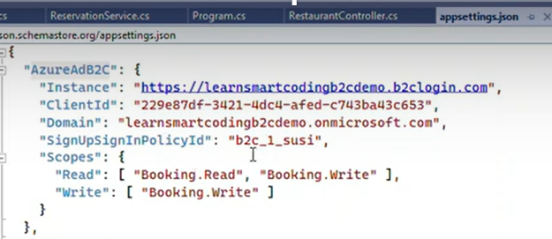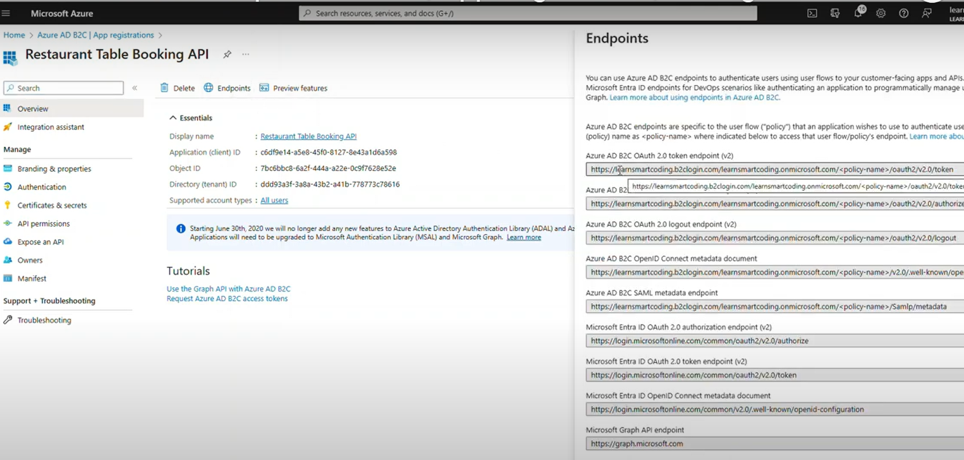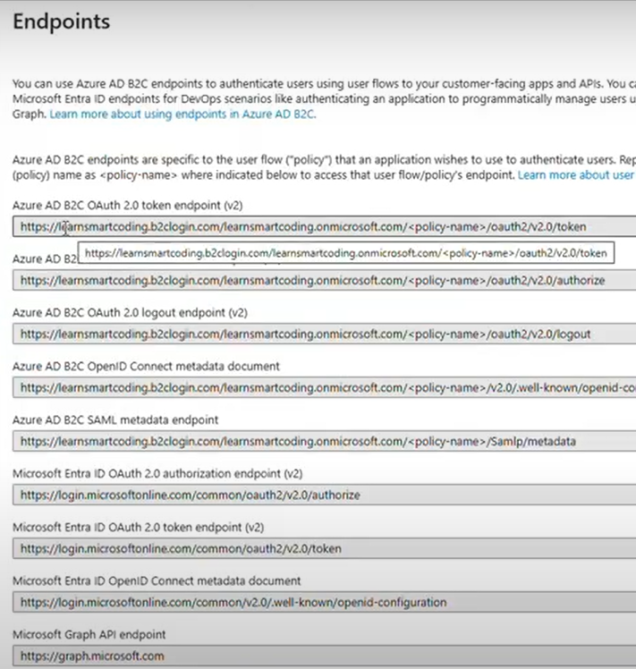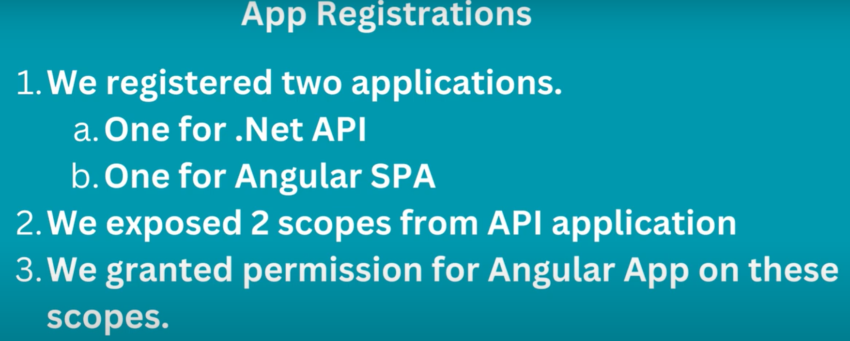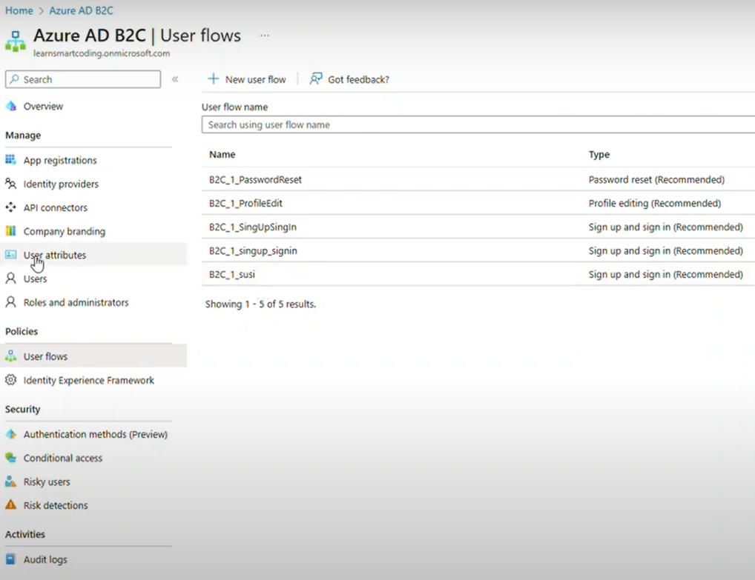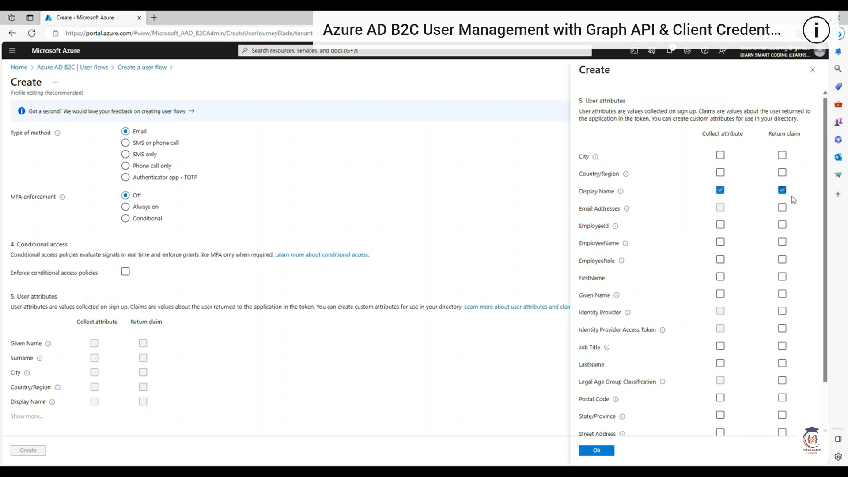profile edit page

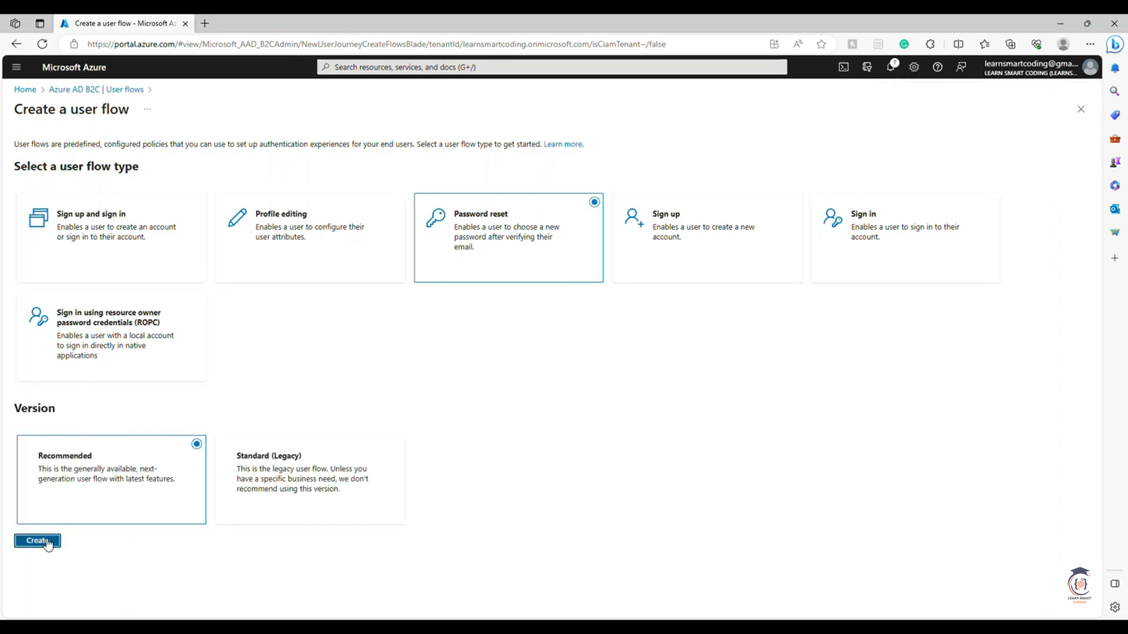

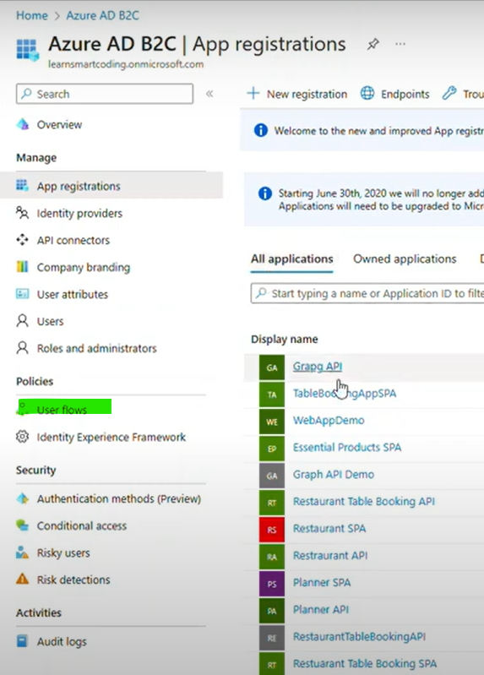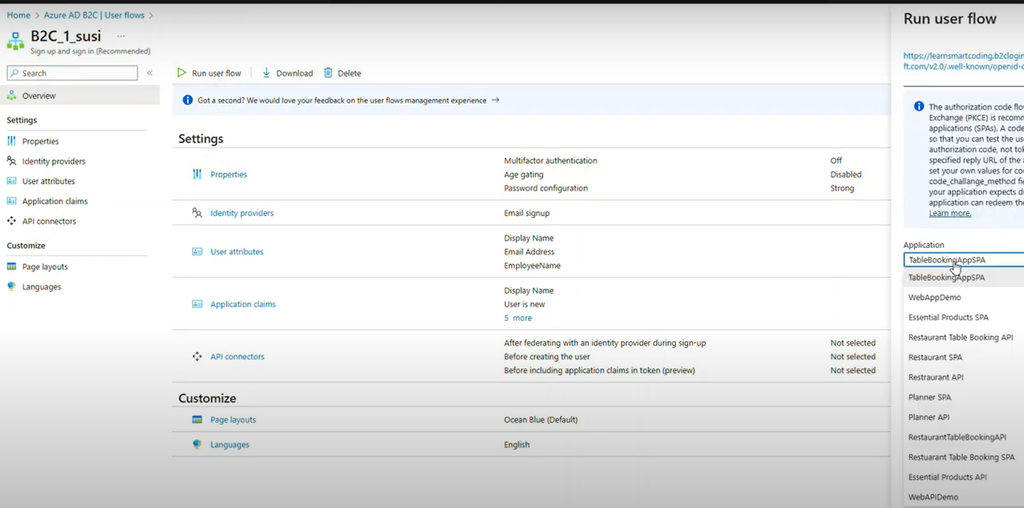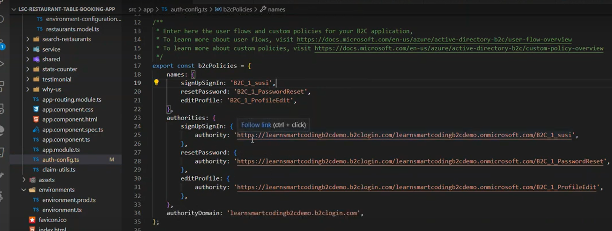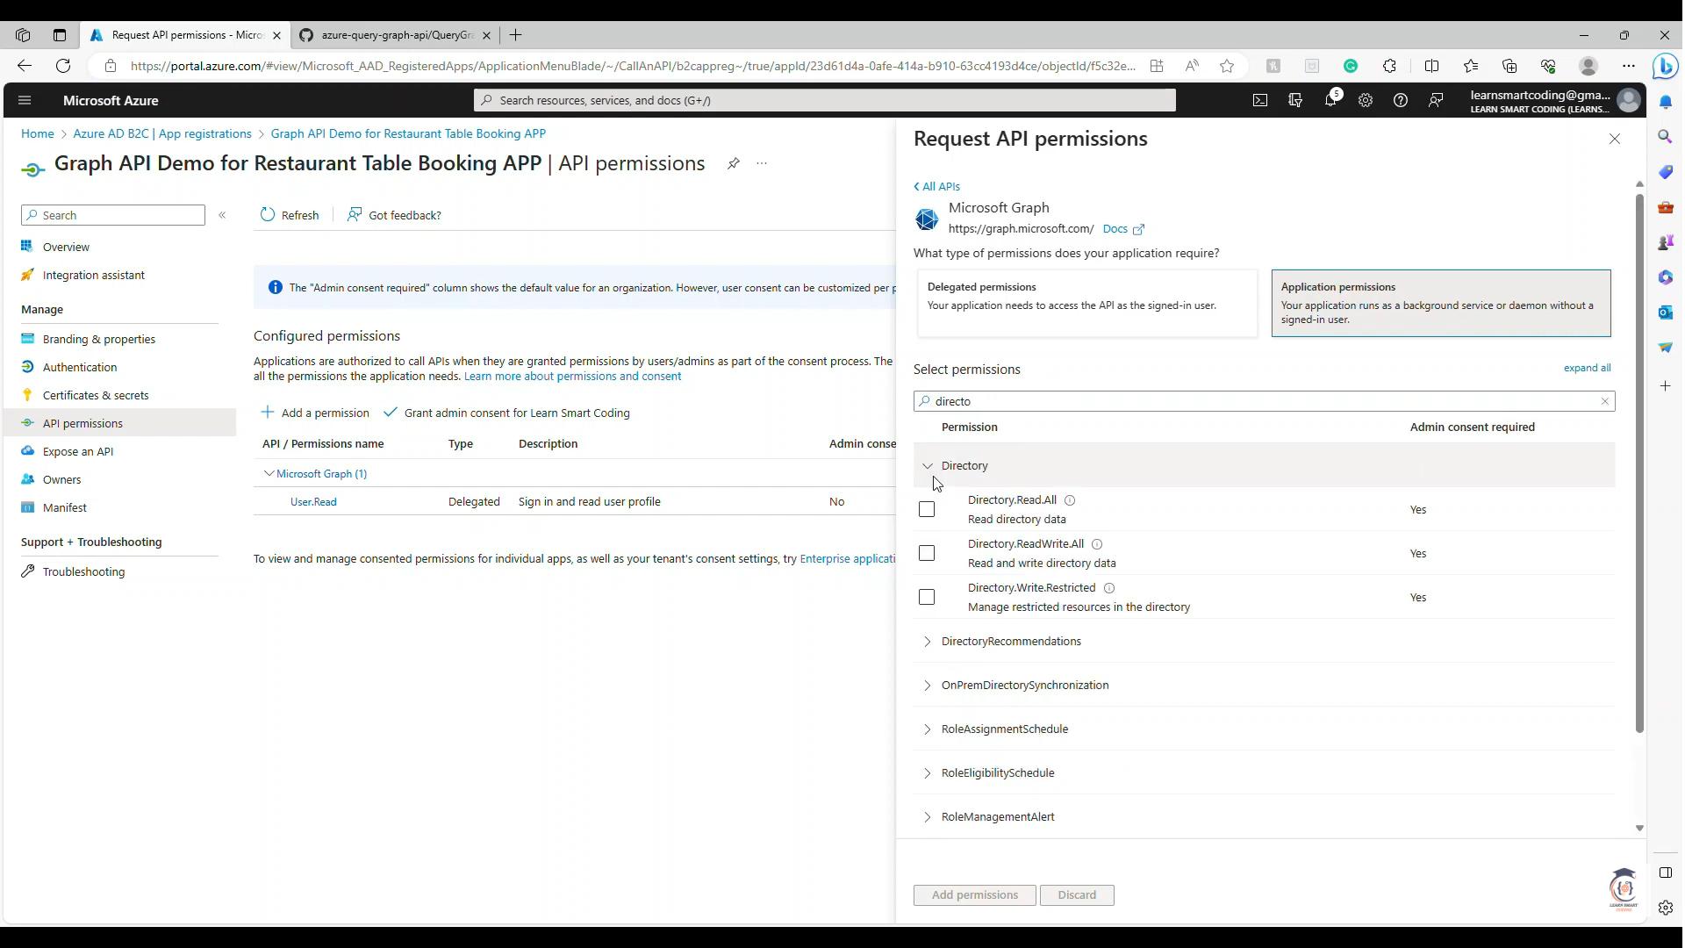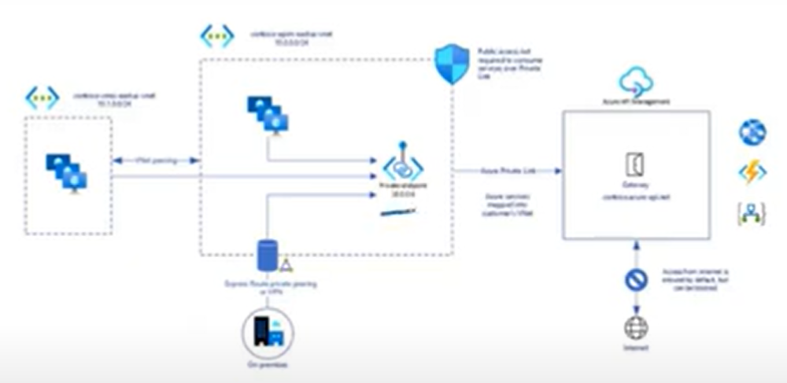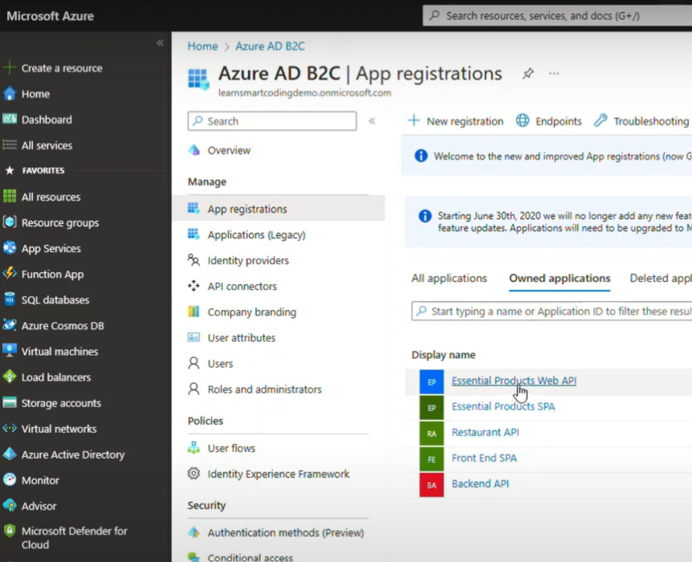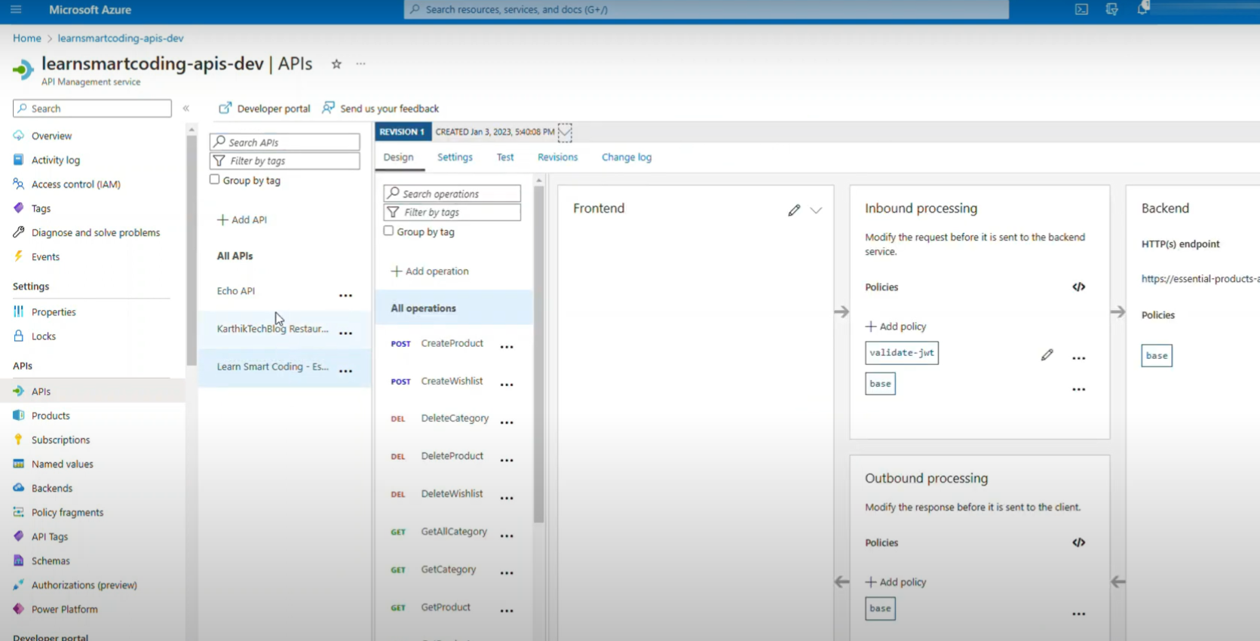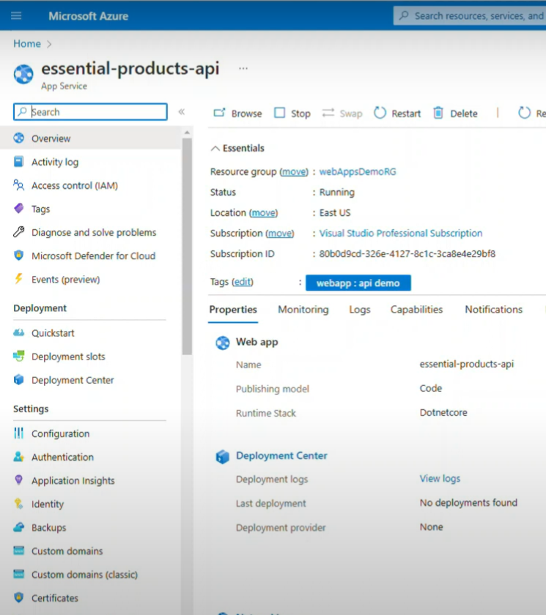

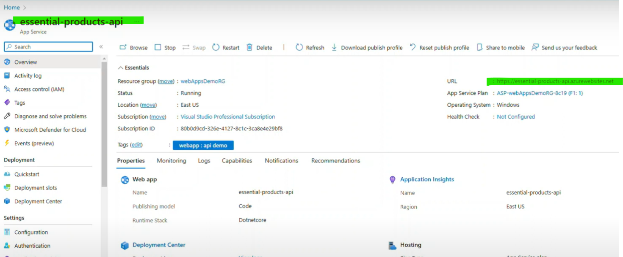

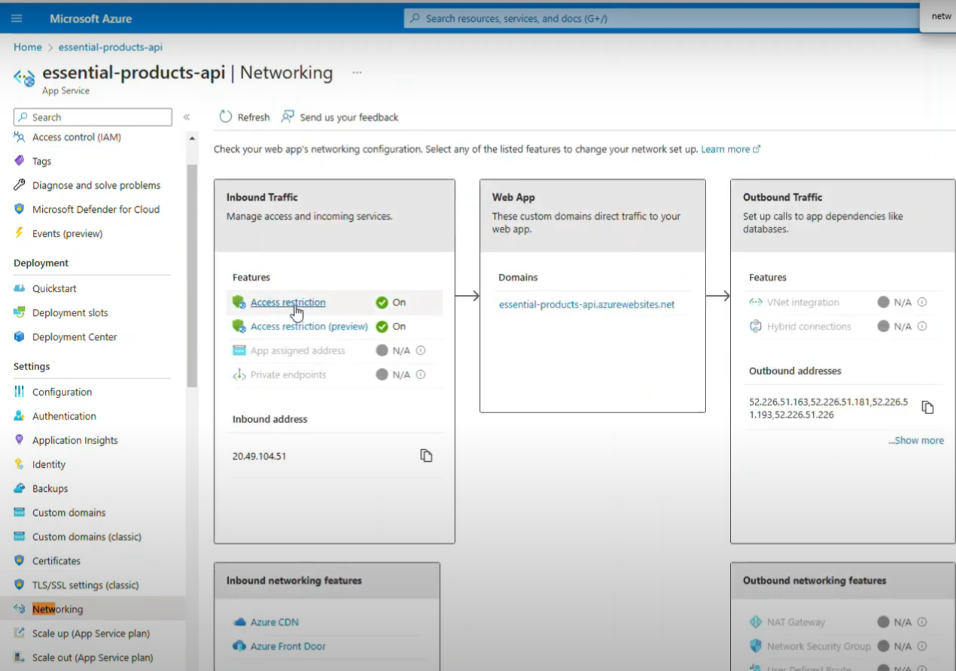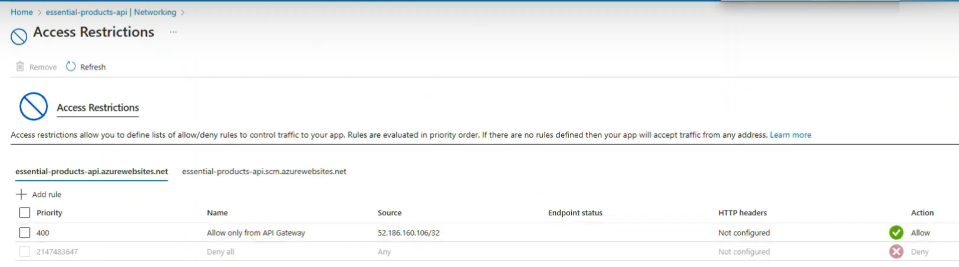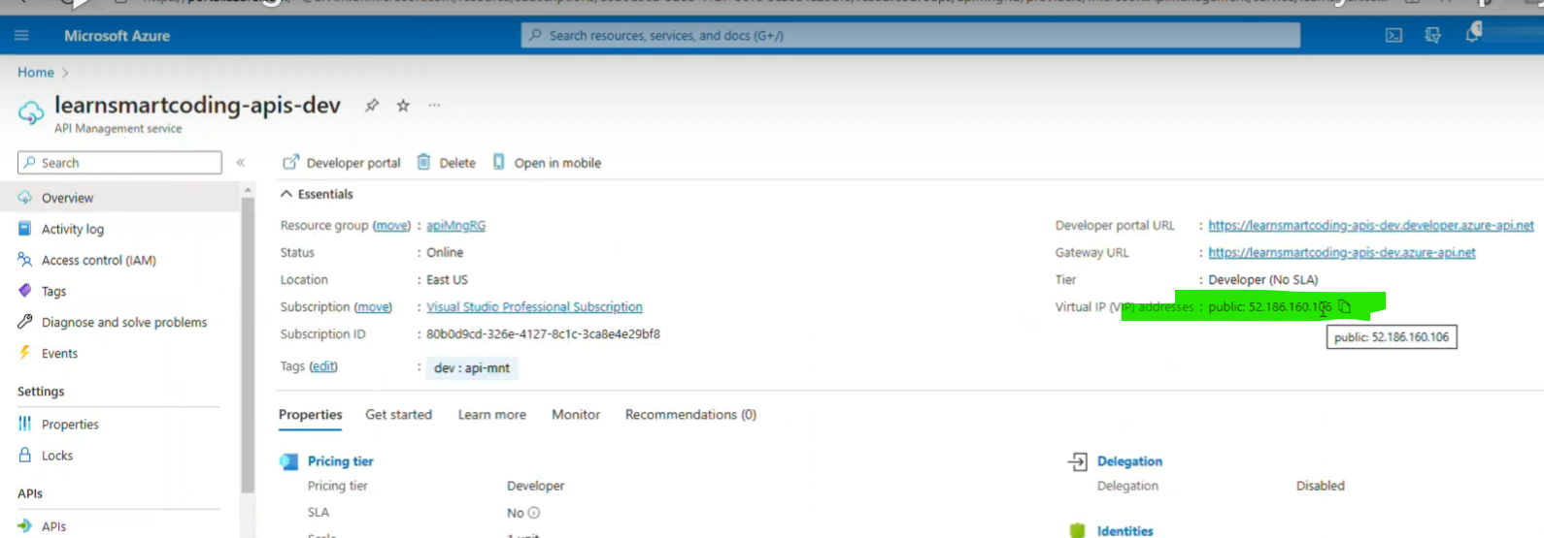

Url link , Audience, Issuer

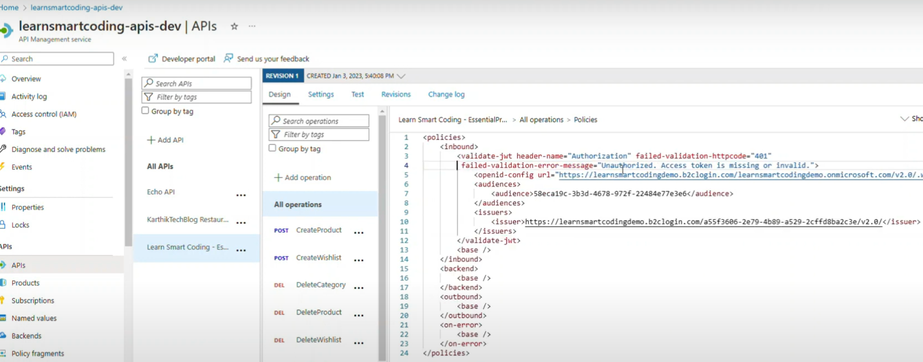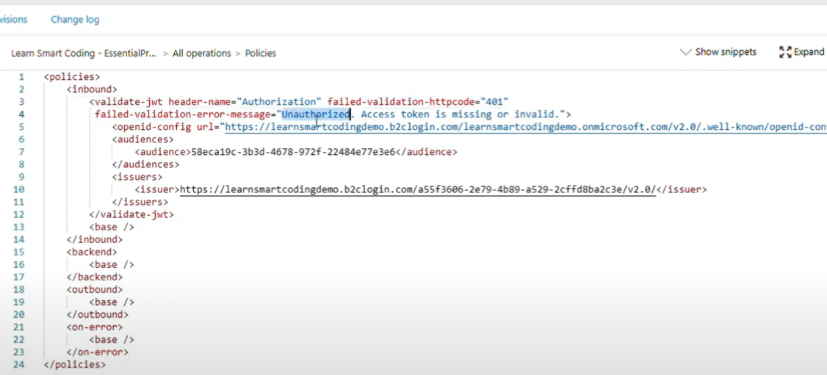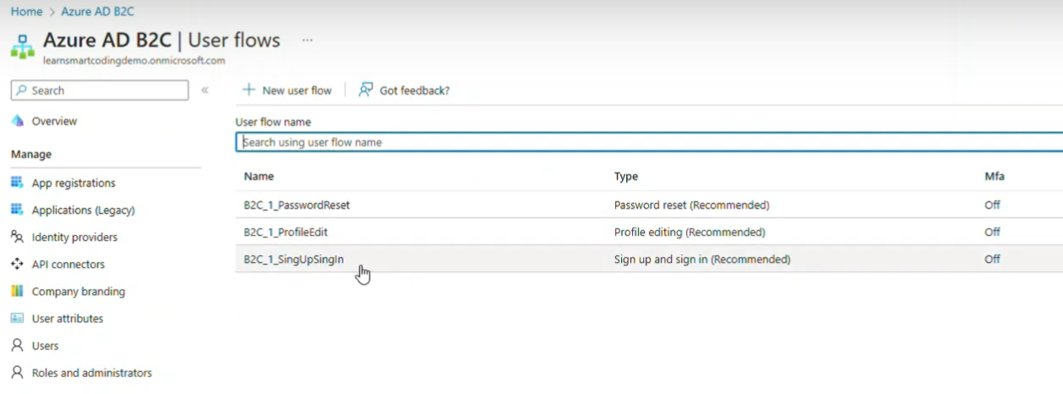

Click on Run Userflow

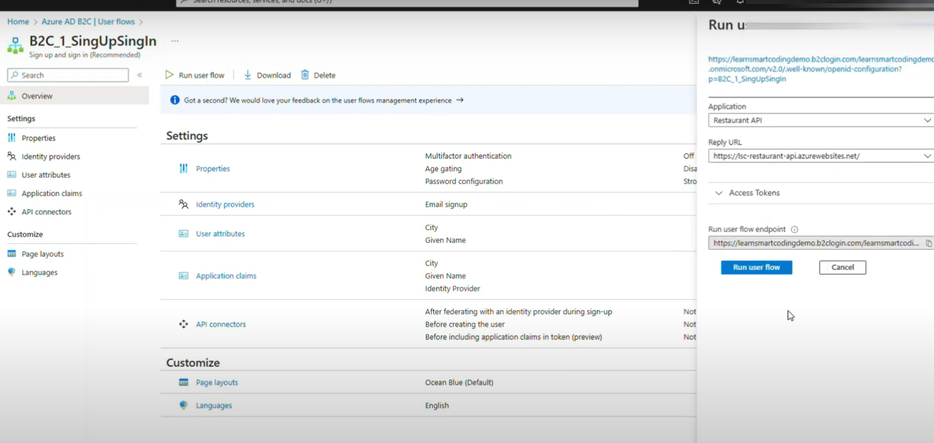

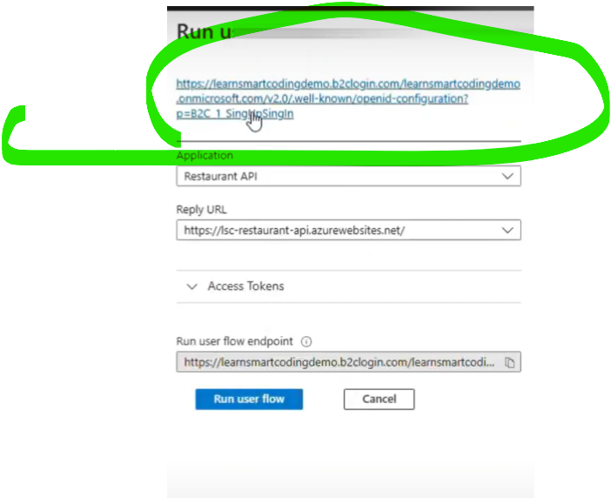

Paste url here…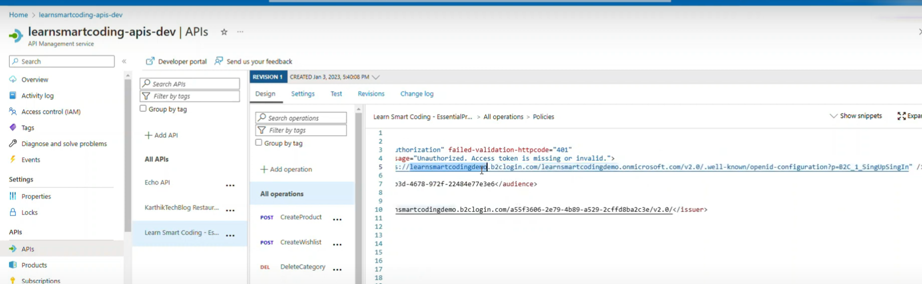

Inside url (audience)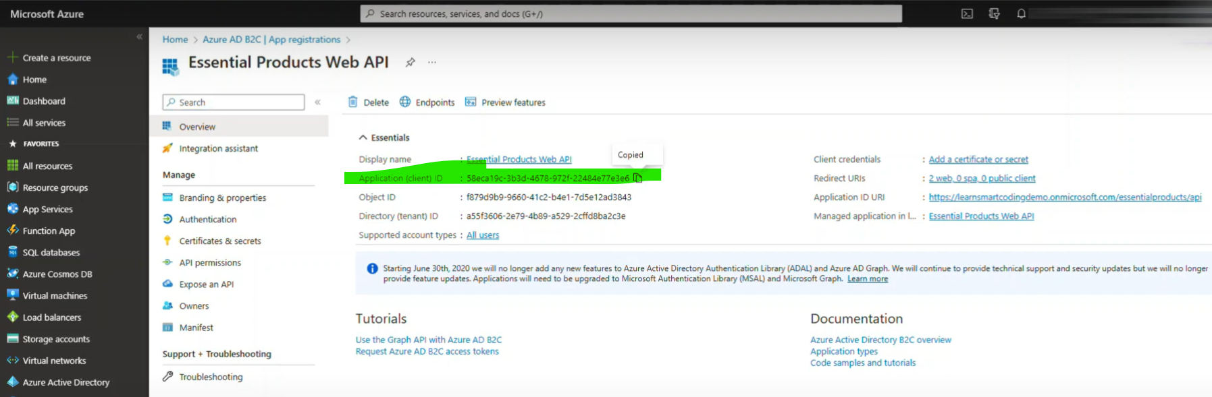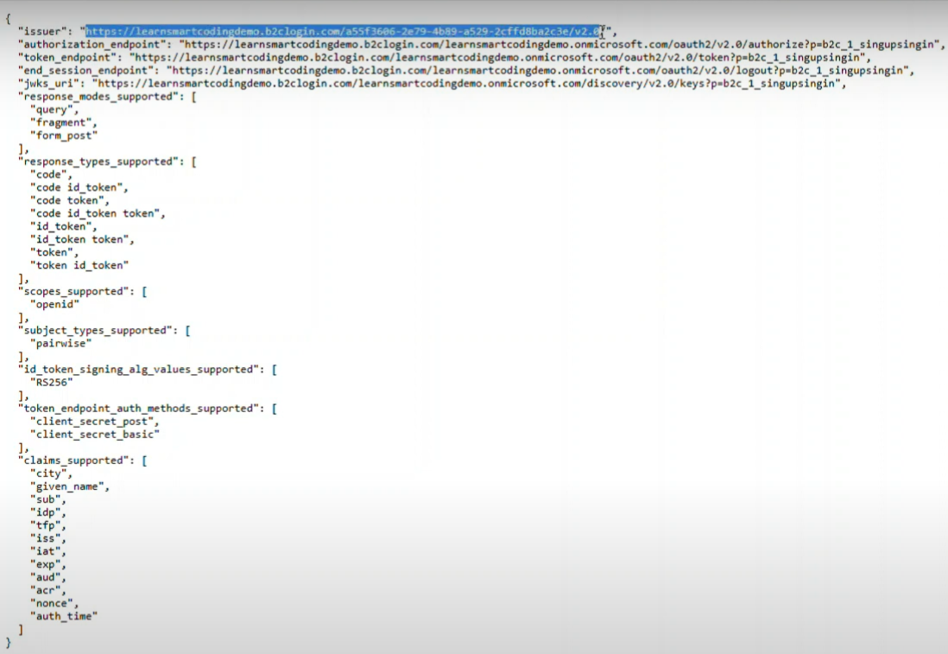

Now from UI Side

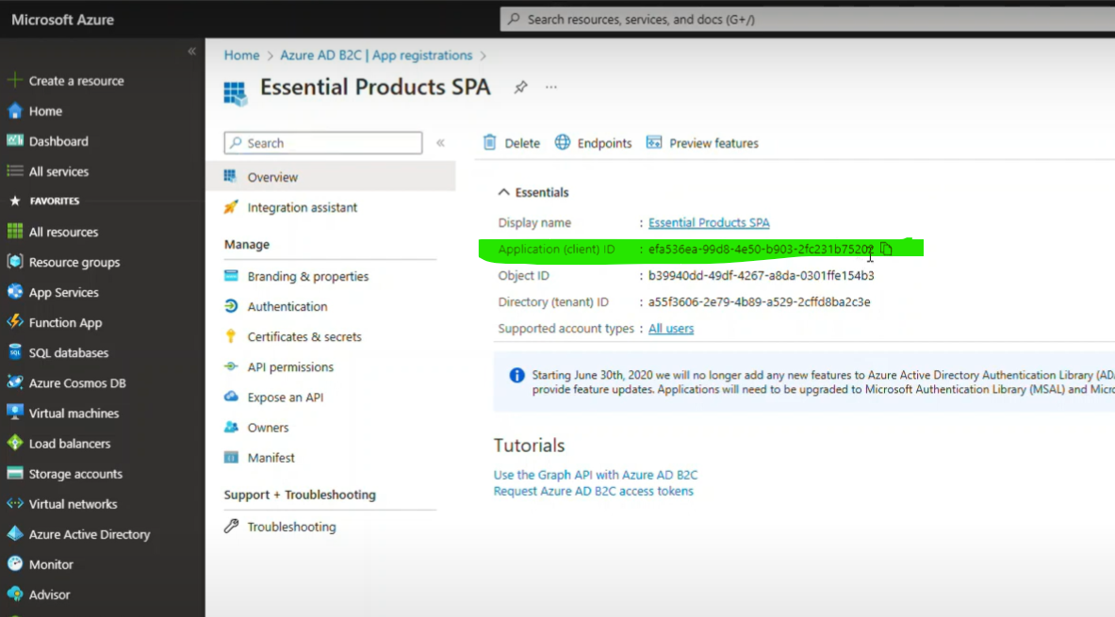

Client id for uI replace

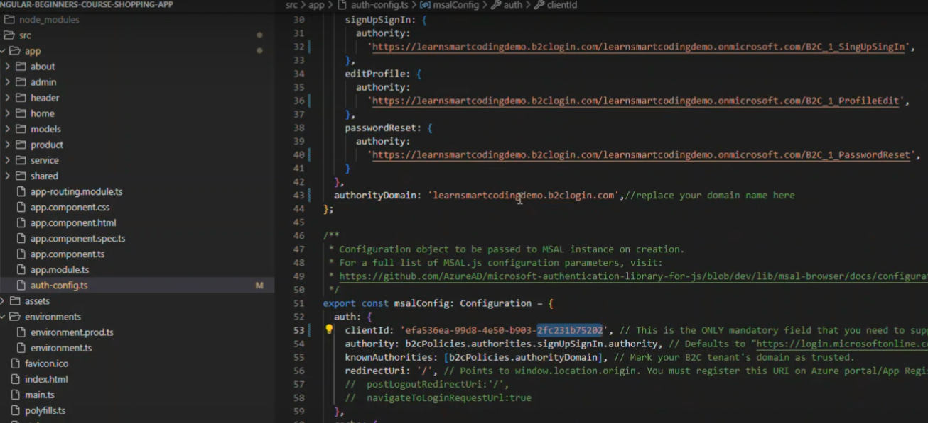

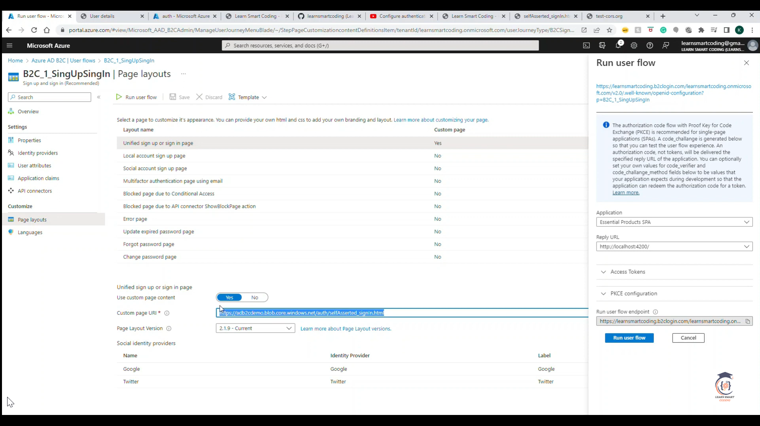

CDN

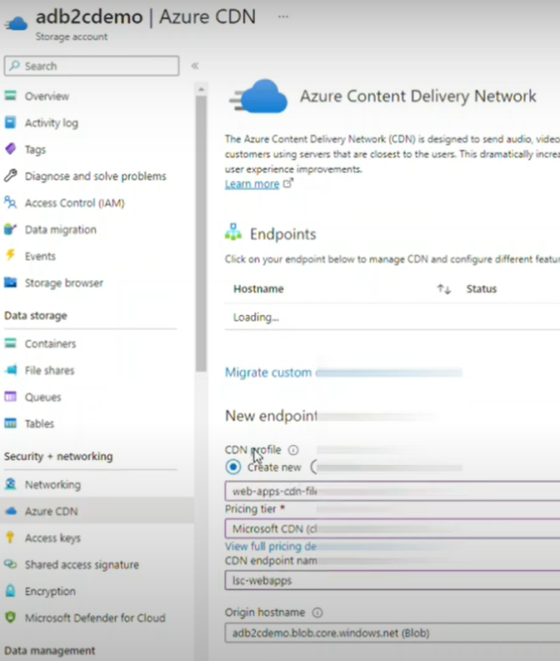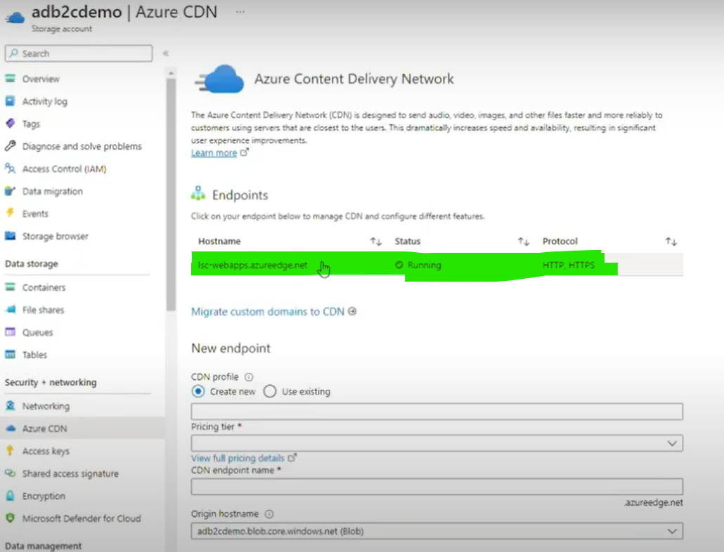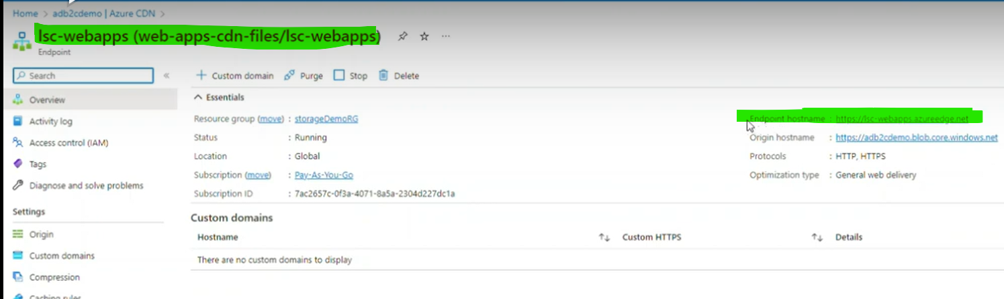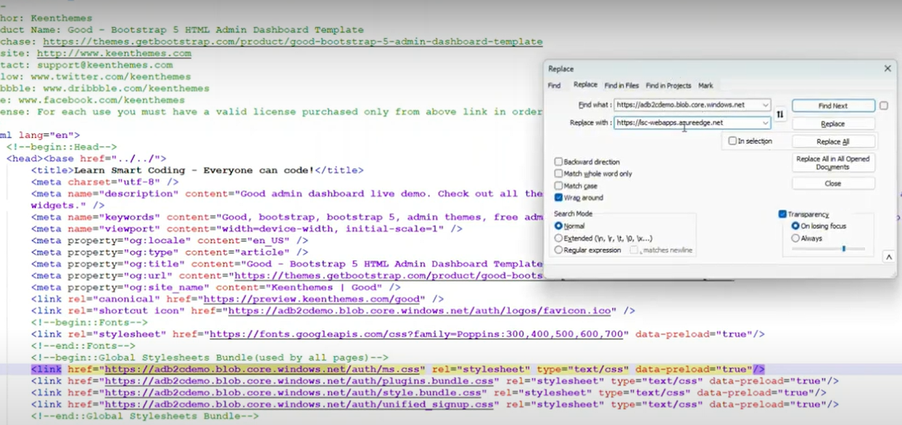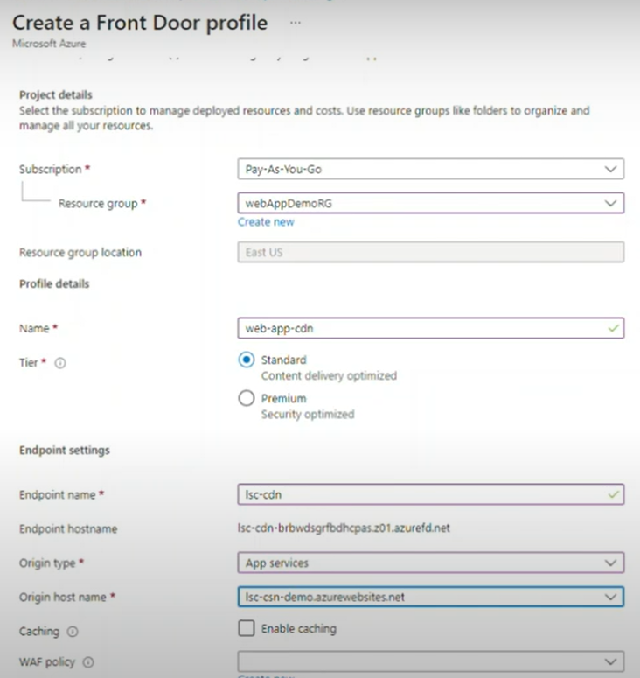

Google sign in

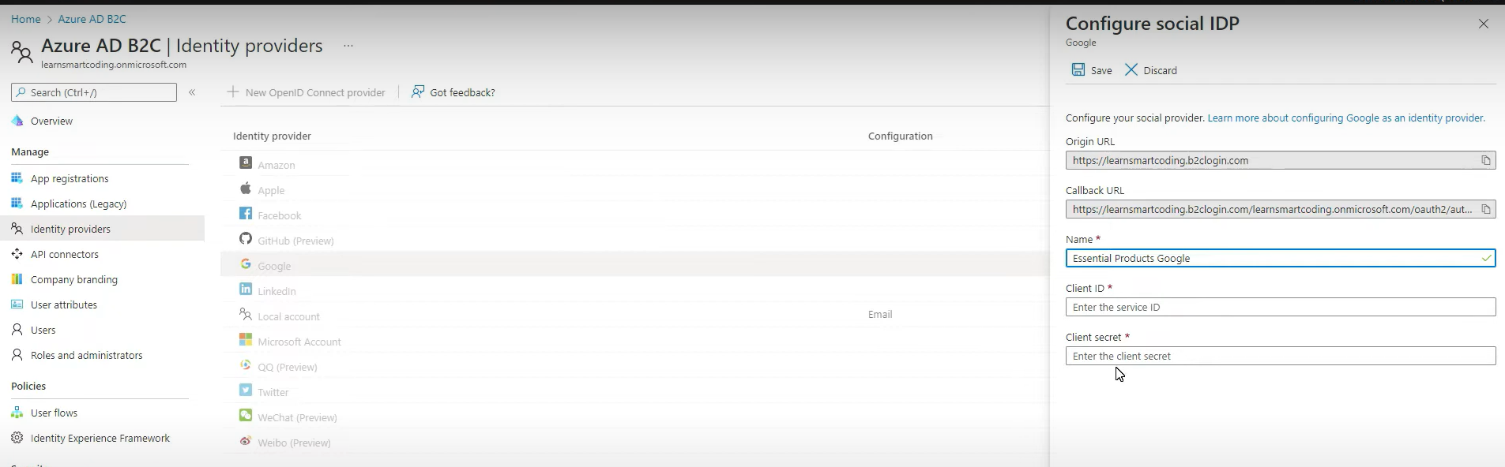

Here’s an expanded table format for **Solution Architect interview preparation** that highlights **key best practices** with additional examples:

| **Best Practice** | **Description** | **Examples** |
| --- | --- | --- |
| **Comprehensive Discovery** | Involve key stakeholders early to gather requirements and understand goals. | - Conduct workshops with business leaders and technical teams. - Ask open-ended questions to uncover tribal knowledge. - Use tools like surveys or interviews for requirement gathering. |
| **Document Everything** | Maintain detailed documentation for all solution aspects. | - Create architecture diagrams using tools like **Visio** or **Lucidchart**. - Document functional and non-functional requirements. - Maintain an updated backlog and version-controlled artifacts. |
| **Iterate and Validate** | Continuously iterate on the solution and validate with stakeholders. | - Develop **Proof of Concepts (POCs)** to validate technical feasibility. - Use Agile sprints for iterative delivery. - Gather regular feedback via demos or stand-up meetings. |
| **Stay Responsive and Available** | Be available to address concerns and provide ongoing support. | - Set up **SLAs** for timely responses. - Offer post-implementation support plans. - Be proactive in resolving issues and answering queries. |
| **Demonstrate Value Clearly** | Showcase how the solution aligns with business goals and delivers ROI. | - Present use-case scenarios demonstrating business benefits. - Use metrics like cost savings, scalability, and performance improvements. - Provide comparative analysis between existing systems and the proposed solution. |
| **Ensure Ease of Integration** | Design solutions that integrate seamlessly with existing systems. | - Use Azure services like **Azure Logic Apps**, **API Management**, and **Service Bus**. - Conduct integration testing to identify potential issues. - Provide clear integration documentation for developers. |
| **Focus on Scalability and Performance** | Build solutions that can scale with business needs while ensuring performance. | - Leverage Azure PaaS services like **Azure App Services** and **Azure SQL Database**. - Use tools like **Azure Monitor** and **Application Insights** for performance monitoring. - Conduct load testing with tools like **JMeter**. |
| **Optimize Cost** | Design cost-effective solutions without compromising quality. | - Use Azure **Cost Management** to monitor spending. - Implement auto-scaling for resources to optimize usage. - Choose the right Azure pricing model (Pay-As-You-Go vs Reserved Instances). |
| **Provide Training and Documentation** | Ensure end-users and teams can adopt the solution effectively. | - Create user guides, FAQs, and technical documentation. - Conduct training sessions and workshops. - Use tools like **Confluence** or **SharePoint** for knowledge sharing. |
| **Security and Compliance** | Design solutions that meet security and regulatory requirements. | - Implement Azure **Security Center** and **Azure Policy**. - Follow best practices for data encryption, identity management, and access control. - Ensure compliance with standards like GDPR, HIPAA, or ISO. |

**"As a .NET Azure Solution Architect, I’ve encountered several challenges during solution design and implementation. Here are a few examples and how I resolved them:"**

**1. Challenge: Understanding Complex Business Requirements**

* **Situation:**  
  At the start of a project, the requirements were unclear, and stakeholders had different interpretations of the business objectives. This ambiguity made it difficult to design a solution aligned with their goals.
* **Resolution:**
  + Conducted **comprehensive discovery sessions** involving key stakeholders to gather and clarify requirements.
  + Used **active listening** techniques to uncover hidden pain points and tribal knowledge.
  + Developed a **Proof of Concept (POC)** to demonstrate the solution's feasibility and ensure alignment with business goals.
  + Maintained detailed **documentation** and iteratively validated the requirements with stakeholders through regular reviews.
* **Outcome:**  
  The POC provided clarity, and the solution was aligned with business objectives, leading to stakeholder confidence and successful project delivery.

**2. Challenge: Integrating Azure Solutions with Legacy Systems**

* **Situation:**  
  The customer had an on-premises legacy system that needed integration with Azure services. The legacy system lacked proper APIs and was incompatible with modern Azure components.
* **Resolution:**
  + Performed a **thorough assessment** of the existing system to identify integration challenges.
  + Leveraged **Azure Logic Apps** and **Azure API Management** to create a middleware layer for seamless integration.
  + Used **Azure Service Bus** for asynchronous messaging to ensure decoupling between the systems.
  + Conducted **integration testing** to validate the solution and provided clear documentation for the development team.
* **Outcome:**  
  The legacy system was successfully integrated with Azure services, ensuring smooth data flow and minimal disruption to operations.

**3. Challenge: Managing Performance and Scalability**

* **Situation:**  
  A customer needed a solution to handle unpredictable spikes in traffic, but their current infrastructure couldn’t scale dynamically, causing performance bottlenecks.
* **Resolution:**
  + Designed a scalable architecture using **Azure App Services** and **Azure SQL Database** with auto-scaling enabled.
  + Used **Azure Front Door** and **Azure CDN** to improve global availability and latency.
  + Implemented monitoring using **Azure Monitor** and **Application Insights** to proactively identify performance issues.
  + Conducted **load testing** to validate the system’s ability to handle peak traffic.
* **Outcome:**  
  The solution could dynamically scale to handle traffic spikes, ensuring high availability and performance, while optimizing costs.

**4. Challenge: Cost Management and Optimization**

* **Situation:**  
  The customer was concerned about rising Azure costs as their cloud adoption increased.
* **Resolution:**
  + Analyzed resource utilization using **Azure Cost Management** and identified underutilized resources.
  + Implemented **auto-scaling** and rightsized compute resources to match actual demand.
  + Recommended switching to **Reserved Instances** for predictable workloads to reduce costs.
  + Educated the team on cost optimization best practices, like shutting down non-production environments during off-hours.
* **Outcome:**  
  The customer achieved a **30% reduction in Azure costs** without compromising performance or functionality.

**5. Challenge: Driving Adoption and Training Teams**

* **Situation:**  
  The end-users and development teams were hesitant to adopt the new Azure-based solution due to a lack of understanding and training.
* **Resolution:**
  + Created **detailed documentation**, including architecture diagrams, user guides, and FAQs.
  + Conducted **training workshops** to educate the teams on Azure services and solution usage.
  + Stayed **responsive and available** to address queries and provide post-implementation support.
* **Outcome:**  
  The teams were able to adopt the solution successfully, improving productivity and reducing resistance to change.

| **Challenge Area** | **Challenge** | **Resolution** | **Outcome** |
| --- | --- | --- | --- |
| **Solution Design** | Business requirements were ambiguous, and no clear solution design existed. | - Conducted **requirement workshops** with stakeholders to clarify scope. - Created a **high-level architecture diagram** aligned with business goals. - Developed a **Proof of Concept (POC)** to validate the solution feasibility. | - The solution design was approved, ensuring alignment with business objectives and technical feasibility. |
| **Technical Leadership** | Development teams lacked understanding of Azure best practices and tools. | - Provided **technical guidance** and best practices for Azure services (e.g., App Services, Azure Functions, and SQL Database). - Conducted **training sessions** on CI/CD pipelines using Azure DevOps. | - Teams gained confidence in Azure tools, leading to better implementation and faster delivery. |
| **Stakeholder Engagement** | Non-technical stakeholders struggled to understand architectural decisions. | - Created **simplified diagrams** and presentations to explain the architecture. - Provided **use-case scenarios** to demonstrate the solution’s value. | - Stakeholders approved the solution, fostering trust and alignment across business and technical teams. |
| **Integration and Deployment** | Integrating Azure solutions with legacy on-premises systems was challenging. | - Used **Azure Logic Apps** and **API Management** to enable seamless integration. - Conducted thorough **integration testing** to ensure compatibility and performance. | - The integration was successful, ensuring smooth data flow between legacy and cloud systems. |
| **Performance Optimization** | Application faced **performance bottlenecks** under high traffic. | - Implemented **auto-scaling** in Azure App Services. - Optimized database queries using indexing and caching with **Azure Redis Cache**. - Used **Azure Monitor** to identify and resolve performance issues. | - Improved response times by 50% and ensured the system could handle peak loads seamlessly. |
| **Cost Management** | Rising Azure costs due to inefficient resource usage. | - Analyzed costs using **Azure Cost Management**. - Implemented **auto-scaling** and rightsized resources. (**Virtual Machine Scale Set**. • Set the **minimum**, **maximum**, and **default** instance counts.  • Define **rules** for scaling (e.g., scale out when CPU usage > 70% for 5 minutes).  **Set Up Load Balancing** (optional):   * Integrate with an Azure Load Balancer to distribute traffic evenly.   - Suggested **Reserved Instances** for predictable workloads. | - Achieved a 30% reduction in cloud costs without compromising performance or scalability. |
| **Documentation and Standards** | Lack of proper documentation made it hard for teams to maintain solutions. | - Developed **comprehensive documentation** for architecture, deployment, and integration. - Created a **knowledge base** for future reference using tools like Confluence and SharePoint. | - Teams could maintain and extend the solution easily, reducing dependency on individual knowledge. |
| **Security and Compliance** | Ensuring compliance with security policies and regulatory standards. | - Implemented **Azure Security Center** for proactive monitoring. - Used **RBAC** (Role-Based Access Control) and encryption for data security. - Ensured compliance with GDPR and ISO standards. | - The solution passed security audits and complied with all regulatory requirements. |

**Auto-scaling in Azure App Services**

Azure App Services supports **Auto-Scaling** for web applications, APIs, and mobile backends.

**Steps to Enable Auto-Scaling:**

1. Go to your **App Service** in the Azure Portal.
2. Navigate to **Scale Out (App Service Plan)**.
3. Choose **Custom Auto-Scale**.
4. Set **rules** for scaling based on metrics:
   * **CPU Percentage**
   * **Memory Usage**
   * **HTTP Queue Length**
5. Define minimum and maximum instance counts.

**3. Auto-scaling in Azure Kubernetes Service (AKS)**

In **AKS**, you can scale pods or nodes automatically:

**Horizontal Pod Autoscaler (HPA):**

* Automatically scales the number of pods based on CPU or memory usage.

**Command Example:**

bash

Copy code

kubectl autoscale deployment my-deployment --cpu-percent=50 --min=2 --max=10

**Cluster Autoscaler:**

* Adjusts the number of nodes in the AKS cluster based on pending pods.

**Example Settings**:

* Minimum nodes: 1
* Maximum nodes: 5

Great question! Both **VMSS (Virtual Machine Scale Sets)** and **AKS (Azure Kubernetes Service)** offer scaling and resource management, but they serve different purposes and operate at different levels. If your goal is to **restart or scale pods**, AKS offers distinct advantages over VMSS. Let’s break it down.

**1. Level of Abstraction**

* **VMSS (Virtual Machine Scale Sets)**:
  + Operates at the **infrastructure level** (VMs).
  + It scales or restarts entire Virtual Machines.
  + You are managing VMs, operating systems, and application deployments.
* **AKS (Azure Kubernetes Service)**:
  + Operates at the **application level** (containers/pods).
  + It restarts or scales **pods** (individual container instances) instead of entire VMs.
  + Kubernetes abstracts away VM management, allowing you to focus on containerized workloads.

**2. Granularity and Efficiency**

* **VMSS**:
  + If a single application or service running on a VM crashes, the entire VM might need to restart, which can take time (minutes).
  + Scaling VMs means spinning up or down whole machines, which is resource-heavy and slower.
* **AKS**:
  + If a pod (container) crashes, Kubernetes automatically restarts the pod within seconds.
  + Kubernetes’ **Horizontal Pod Autoscaler (HPA)** can scale specific microservices (pods) up or down based on metrics like CPU, memory, or custom metrics.
  + Fine-grained scaling is more efficient because you only scale the parts of your application that need it.

**3. Application Deployment and Management**

* **VMSS**:
  + Suitable for **monolithic applications** or workloads that require full VMs.
  + You have to manage VM configurations, OS updates, and deployments manually or through automation tools.
* **AKS**:
  + Ideal for **microservices architectures** and containerized workloads.
  + Kubernetes provides tools like:
    - **Rolling updates**: Deploy updates with zero downtime.
    - **Self-healing**: Automatically restart failed pods.
    - **Load balancing**: Built-in load balancing at the pod level.
  + Easier to manage deployments using YAML files or tools like **Helm**.

**4. Restart Scenarios**

* **VMSS**:
  + If an application fails, the VMSS might restart the **entire VM**, impacting other services running on that VM.
  + Restarting a VM takes longer and consumes more resources.
* **AKS**:
  + If a pod fails, Kubernetes restarts **only the affected pod**, not the entire VM.
  + Restarting a pod is lightweight and happens in seconds.

**5. Cost Considerations**

* **VMSS**:
  + You are paying for entire VMs, even if only part of the VM's resources are being used.
  + Scaling up VMs means higher costs as you provision more machines.
* **AKS**:
  + Pods share underlying nodes, which are more cost-efficient.
  + Kubernetes schedules pods optimally across nodes, reducing waste.

**6. Scalability**

* **VMSS**:
  + Scaling is at the VM level. You can scale out by adding more VMs or scale in by reducing them.
  + Limited to infrastructure-level scaling.
* **AKS**:
  + AKS supports:
    - **Horizontal Pod Autoscaler (HPA)**: Scales pods based on metrics.
    - **Cluster Autoscaler**: Scales the underlying nodes automatically to fit pod demands.
  + Kubernetes provides more dynamic, fine-tuned scaling for applications.

**When to Choose AKS over VMSS?**

1. **Containerized Applications**: If your applications are containerized, AKS is the clear choice for managing and restarting pods efficiently.
2. **Microservices Architecture**: AKS is better suited for microservices that require independent scaling and restarts.
3. **Faster Recovery**: If you need rapid restarts and self-healing, AKS restarts pods much faster than restarting VMs in VMSS.
4. **Cost Efficiency**: AKS optimizes resource usage at the pod level, reducing unnecessary VM overhead.
5. **Orchestration Needs**: Kubernetes offers advanced orchestration features like rolling updates, scaling, and load balancing.

**When to Use VMSS?**

* If you are running traditional, non-containerized workloads or monolithic applications.
* If you need control over the VM infrastructure (e.g., OS-level customization)

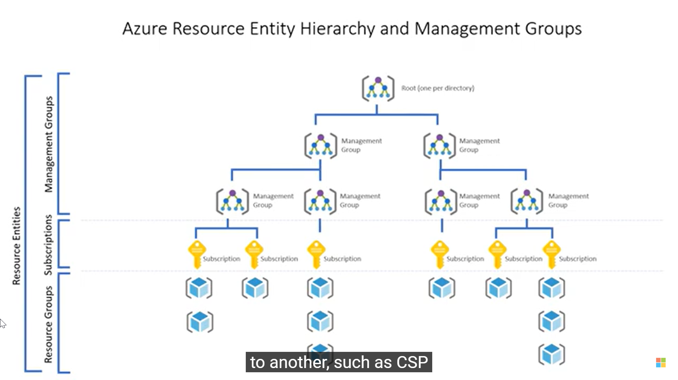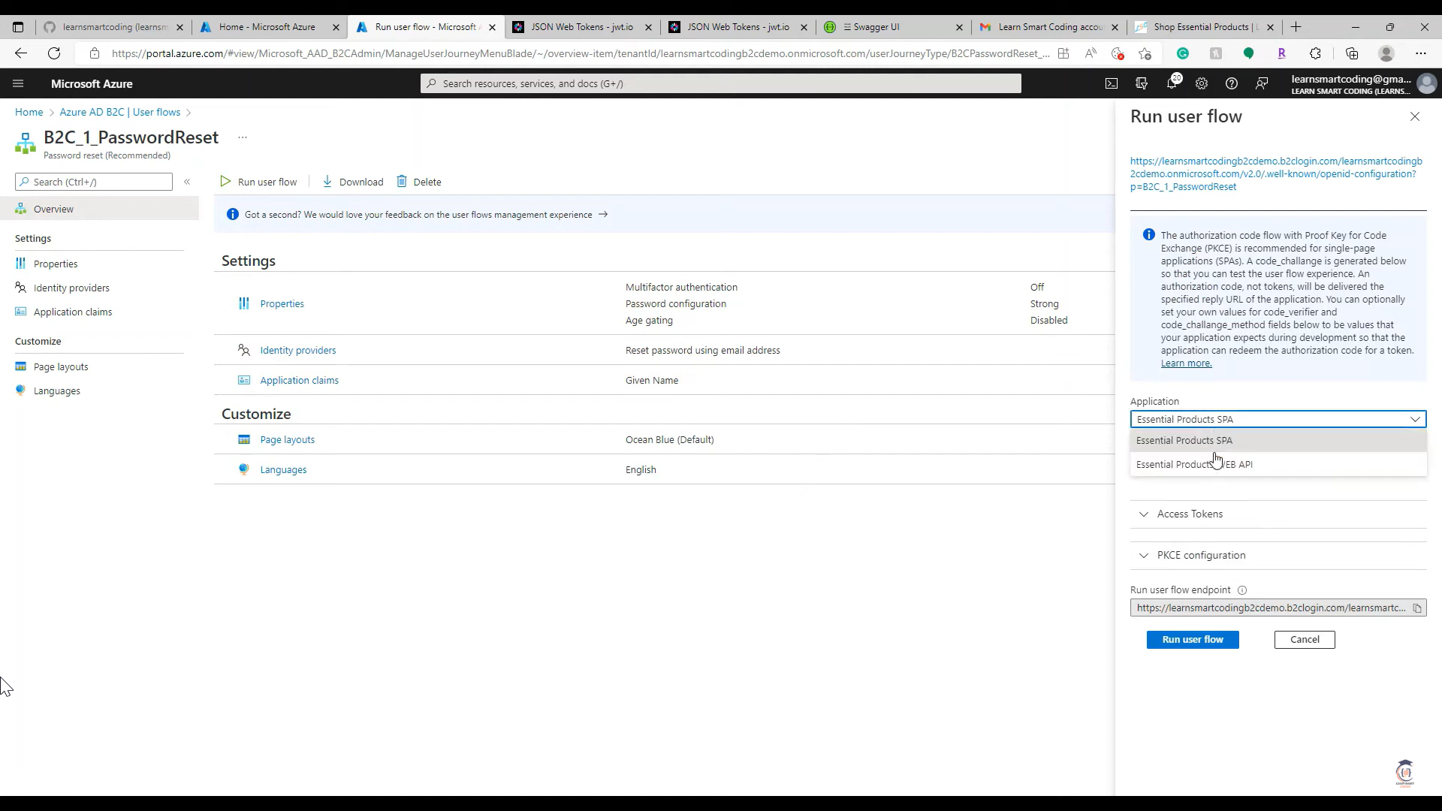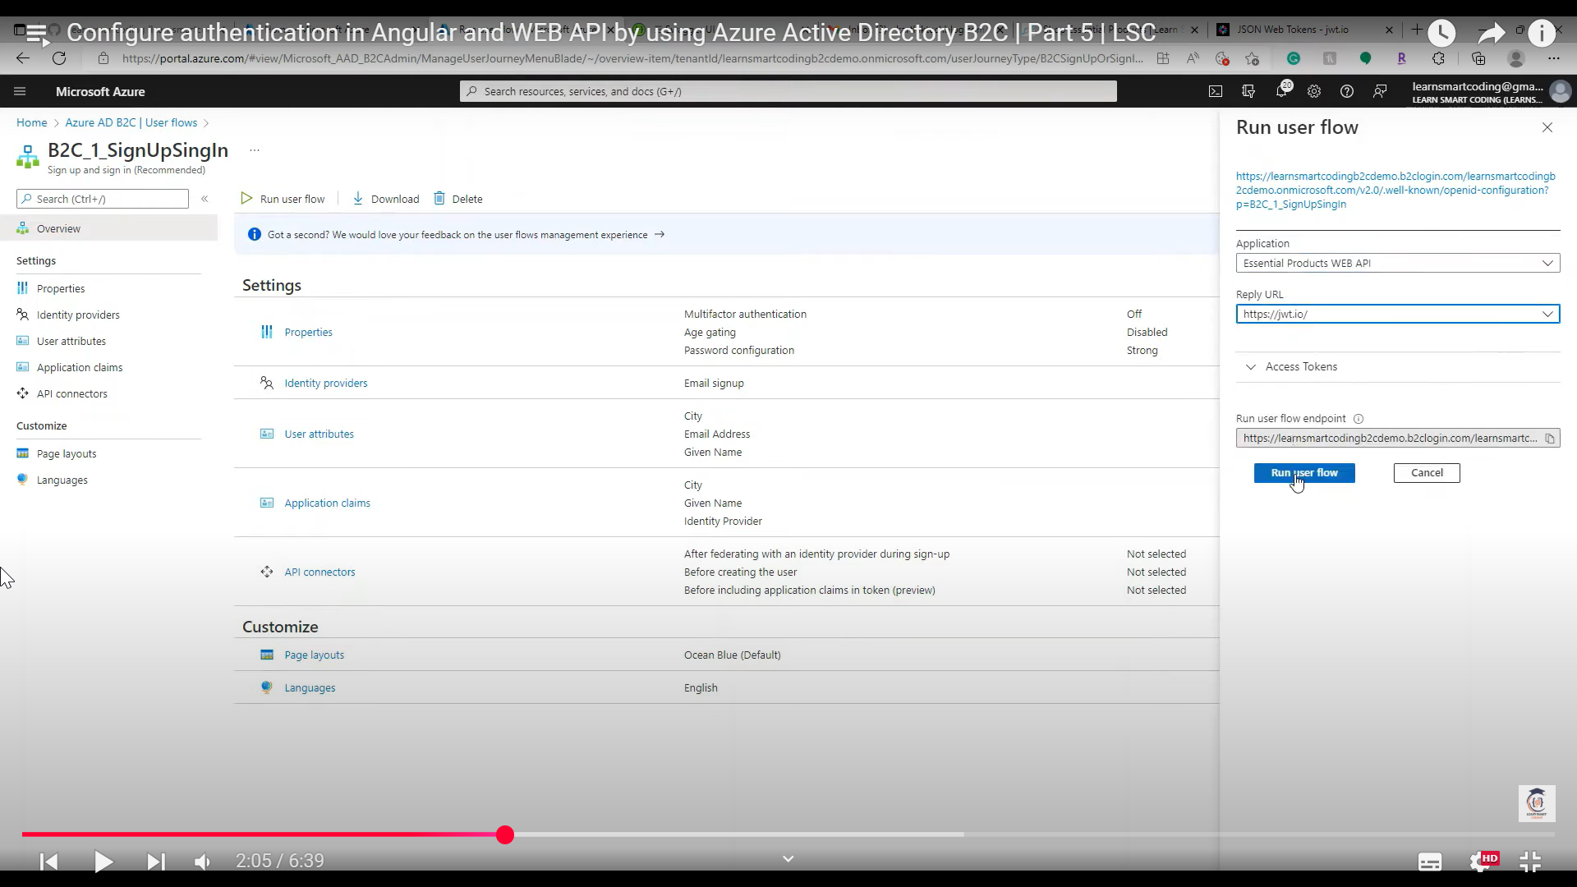

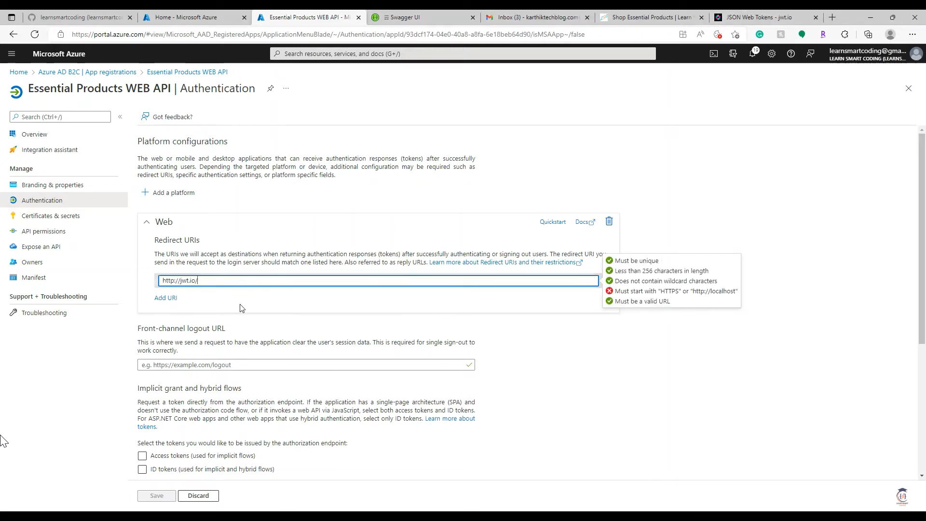

**1. Angular Integration with Azure AD B2C**

**Install MSAL Library**

Run the following commands to add the required libraries:

**npm install @azure/msal-browser @azure/msal-angular**

**Configure MSAL in Angular**

In your app.module.ts, configure the MSAL module:

|  |
| --- |
| import { NgModule } from '@angular/core';  import { BrowserModule } from '@angular/platform-browser';  import { MsalModule, MsalInterceptor, MsalService, MSAL_INSTANCE, MSAL_INTERCEPTOR_CONFIG, MsalInterceptorConfiguration } from '@azure/msal-angular';  import { PublicClientApplication, InteractionType } from '**@azure/msal-browser';**  import { HTTP_INTERCEPTORS, HttpClientModule } from '@angular/common/http';  const b2cPolicies = {  names: {  signUpSignIn: 'B2C_1_signup_signin',  },  authorities: {  signUpSignIn: {  authority: 'https://<tenant-name>.b2clogin.com/<tenant-name>.onmicrosoft.com/B2C_1_signup_signin',  },  },  authorityDomain: '<tenant-name>.b2clogin.com',  };  function MSALInstanceFactory(): PublicClientApplication {  return new PublicClientApplication({  auth: {  clientId: '<spa-client-id>',  authority: b2cPolicies.authorities.signUpSignIn.authority,  redirectUri: 'http://localhost:4200',  },  cache: {  cacheLocation: 'localStorage',  storeAuthStateInCookie: true,  },  });  }  function MSALInterceptorConfigFactory(): MsalInterceptorConfiguration {  return {  interactionType: InteractionType.Redirect,  protectedResourceMap: new Map([  ['https://<api-base-url>/', ['api.read', 'api.write']],  ]),  };  }  @NgModule({  declarations: [/* Your Components */],  imports: [  BrowserModule,  HttpClientModule,  MsalModule.forRoot(MSALInstanceFactory, MSALInterceptorConfigFactory),  ],  providers: [  { provide: HTTP_INTERCEPTORS, useClass: MsalInterceptor, multi: true },  ],  bootstrap: [/* Your Root Component */],  })  export class AppModule {} |

**Add Login and Logout in Angular**

|  |
| --- |
| **i**mport { Component } from '@angular/core';  import { MsalService } from '@azure/msal-angular';  @Component({  selector: 'app-root',  template: `  <button (click)="login()">Login</button>  <button (click)="logout()">Logout</button>  `,  })  export class AppComponent {  constructor(private msalService: MsalService) {}  login() {  this.msalService.loginRedirect();  }  logout() {  this.msalService.logoutRedirect();  }  } |

**2. API Integration with Azure AD B2C**

**Add Authentication Middleware in .NET API**

**dotnet add package Microsoft.AspNetCore.Authentication.JwtBearer**

Update Program.cs or Startup.cs to add JWT Bearer authentication:

|  |
| --- |
| using Microsoft.AspNetCore.Authentication.JwtBearer;  using Microsoft.IdentityModel.Tokens;  var builder = WebApplication.CreateBuilder(args);  **builder.Services.AddAuthentication(JwtBearerDefaults.AuthenticationScheme)**  **.AddJwtBearer(options =>**  {  options.Authority = "https://<tenant-name>.b2clogin.com/<tenant-name>.onmicrosoft.com/B2C_1_signup_signin/v2.0/";  options.Audience = "<api-client-id>";  options.TokenValidationParameters = new TokenValidationParameters  {  ValidateIssuer = true,  ValidIssuer = "https://<tenant-name>.b2clogin.com/<tenant-name>.onmicrosoft.com/v2.0/",  };  });  builder.Services.AddAuthorization();  var app = builder.Build();  app.UseAuthentication();  app.UseAuthorization();  app.MapControllers();  app.Run(); |

**Secure API Endpoints**

|  |
| --- |
| using Microsoft.AspNetCore.Authorization;  using Microsoft.AspNetCore.Mvc;  [ApiController]  [Route("api/[controller]")]  public class ProductController : ControllerBase  {  [HttpGet]  **[Authorize]**  public IActionResult GetProducts()  {  return Ok(new[] { "Product 1", "Product 2" });  }  } |

**3. Test Authentication**

**Test Angular App**

1. Run the Angular app: ng serve.
2. Click **Login** to trigger the Azure AD B2C sign-in flow.
3. After signing in, the MSAL interceptor will automatically attach the token to API requests.

**Test API**

1. Use Postman to test API endpoints:
   * Add the token from the Angular app in the Authorization header:  
     Authorization: Bearer <access_token>.
2. Decode the token at [jwt.io](https://jwt.io) to verify its claims.

**4. Without APIM**

* The above setup works without Azure API Management (APIM). Ensure:
  + Proper token validation in the API.
  + Scopes (api.read, api.write) are enforced in your application logic.